PHASE 4 – INCIDENT CLASSIFICATION & PRIORITY
Incident Lifecycle Automation in ServiceNow
Implementation Documentation with ServiceNow Screenshot Evidence

1. Phase Objective
The objective of Phase 4 was to classify the VPN incident correctly and establish its priority using the ServiceNow Impact and Urgency values. Correct classification ensures that the incident reaches the appropriate support team and receives an appropriate priority.

2. Incident Classification
Incident INC0010014 was classified using the ServiceNow Category and Subcategory fields.
Field | Configured Value
Incident | INC0010014
Category | Network
Subcategory | VPN
Assignment Group | Network
Impact | 2 - Medium
Urgency | 2 - Medium
Calculated Priority | 3 - Moderate

3. Priority Assessment
Impact was set to 2 - Medium and Urgency was set to 2 - Medium. ServiceNow consequently displayed Priority 3 - Moderate. This establishes the incident's relative handling priority for the support process.

4. Classification Work Note
Incident classified as Network > VPN. Impact and urgency were assessed as Medium, resulting in Priority 3 - Moderate.

5. Screenshot Evidence
The screenshot below provides the ServiceNow evidence for Phase 4. It shows the Network > VPN classification, Medium impact and urgency, Priority 3 - Moderate, and Network assignment on INC0010014.
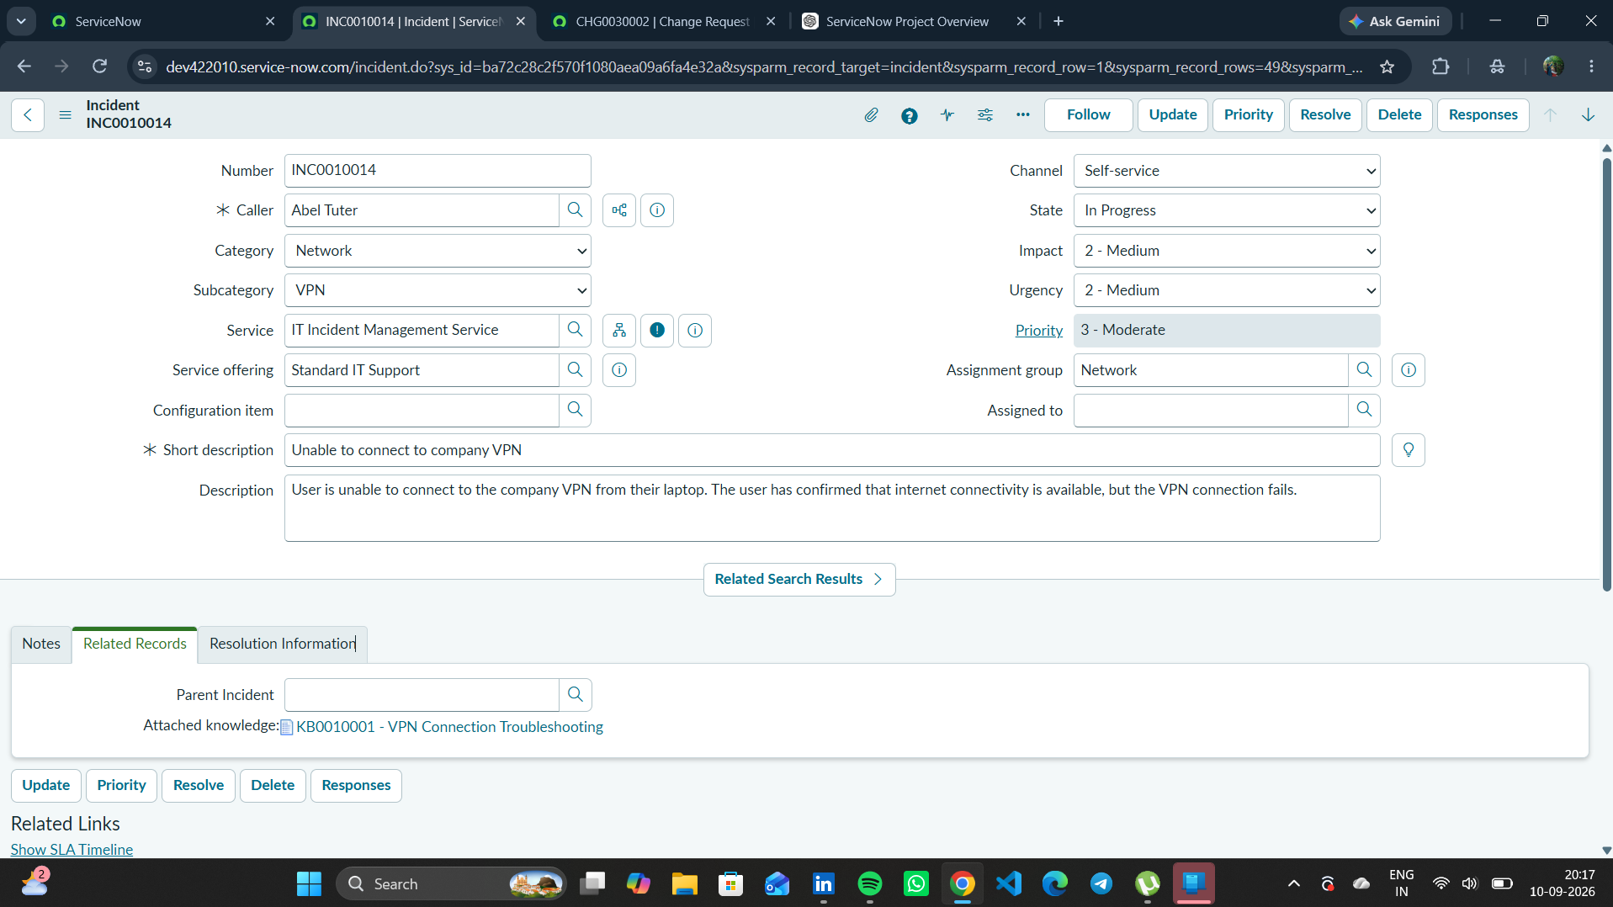
Figure 1. INC0010014 showing Network > VPN classification, Impact 2 - Medium, Urgency 2 - Medium, Priority 3 - Moderate, and Network assignment.

6. Phase 4 Outcome
- The incident was correctly classified as Network > VPN.
- Impact and Urgency were both set to 2 - Medium.
- ServiceNow calculated Priority 3 - Moderate.
- The incident was assigned to the Network support group.
- The classification and priority assessment were documented in the incident work notes.
Status: COMPLETED

7. Phase 4 Evidence File
- 01_INC0010014_Classification_Priority.png

